Testing notes and usage:

1. Connect to <http://35.197.189.153:8081/> to test the Employee Management App.

It is hosted on GCP – Centos Instance.

1. Testing is done for all APIs, i.e, API are called from POSTMAN client
2. How to use them is specified in index/home page with example route.
3. Have attached below the screenshot of all the cases tested.
4. All responses are in JSON , request for POST also in JSON
5. All results are paginated

Testcase1 : Home page with example routes and description to all APIs

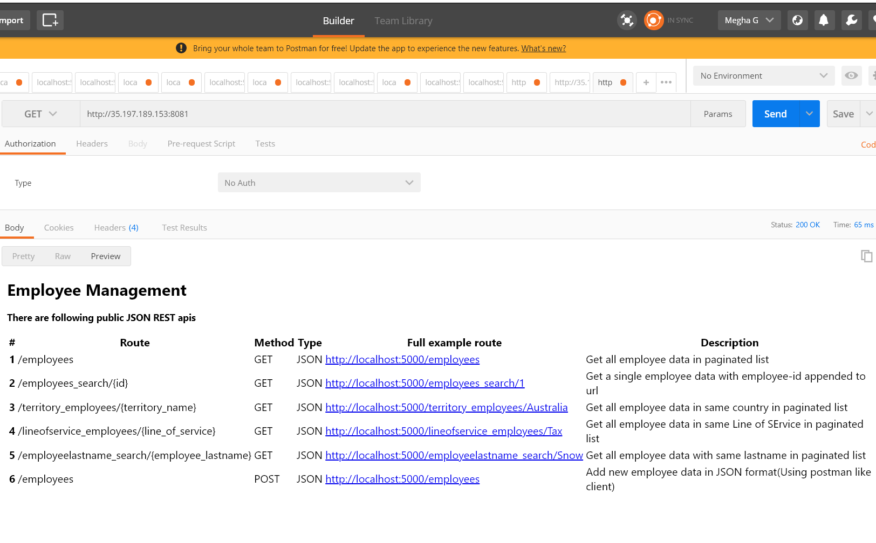

Testcase2 : Display all employees in a paginated list

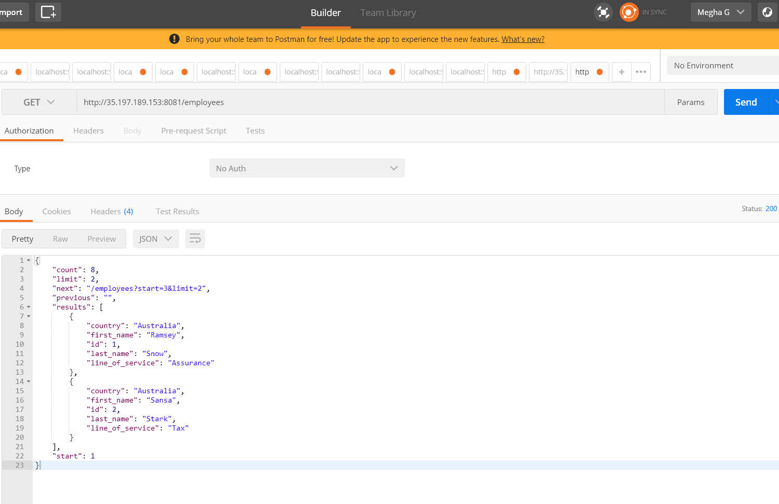

3.Testcase3: Search employee by ID

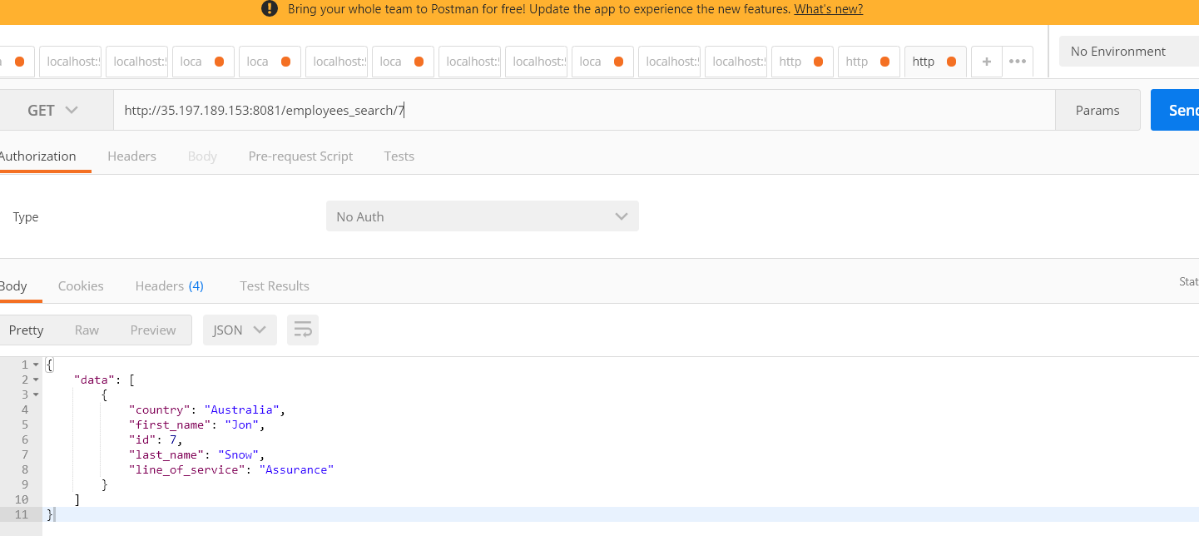

Testcase4: Search all employees in a particular territory - Australia

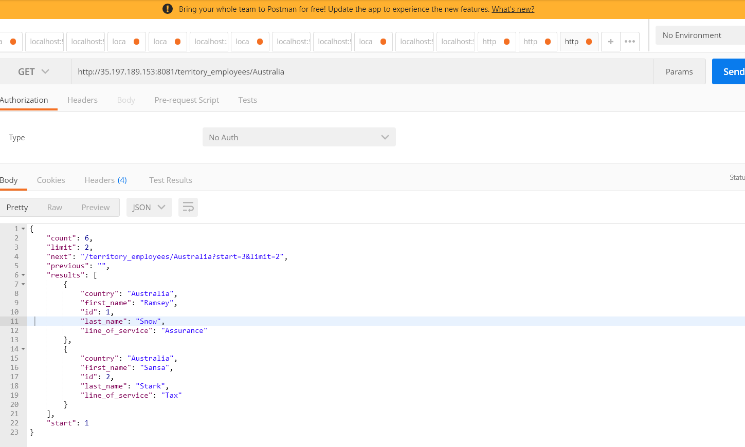

Testcase5: Search for all employees in a Line of service - Tax

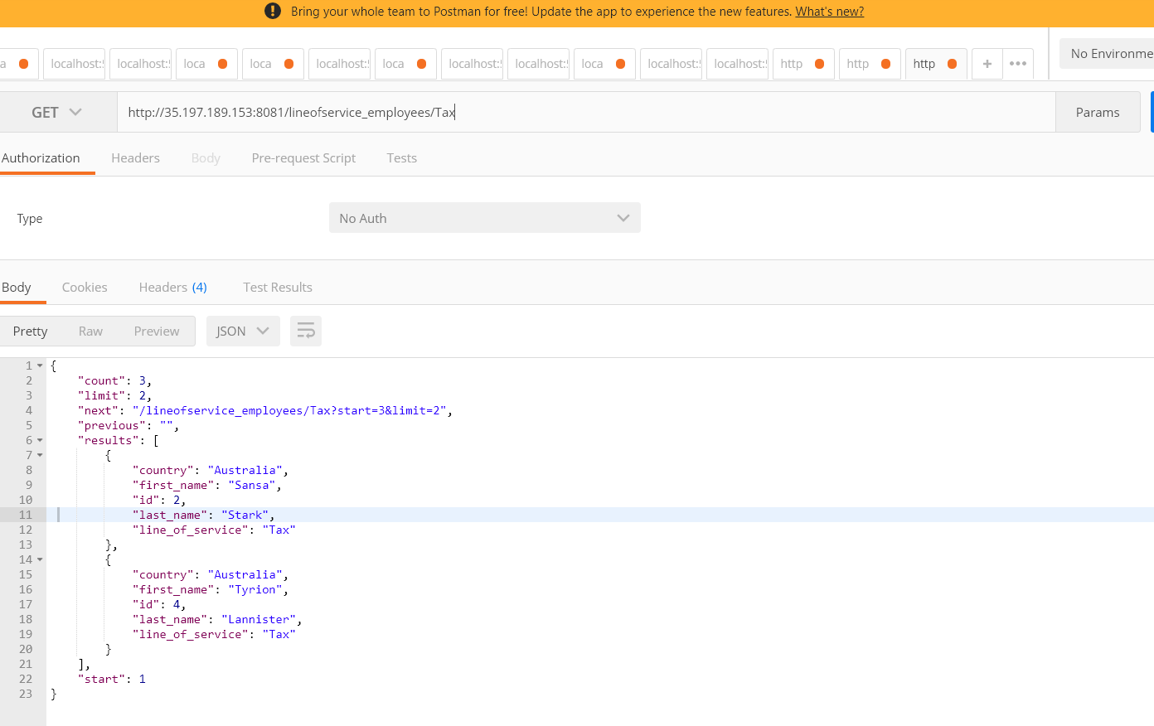

Testcase6: Search by employee last name – Stark

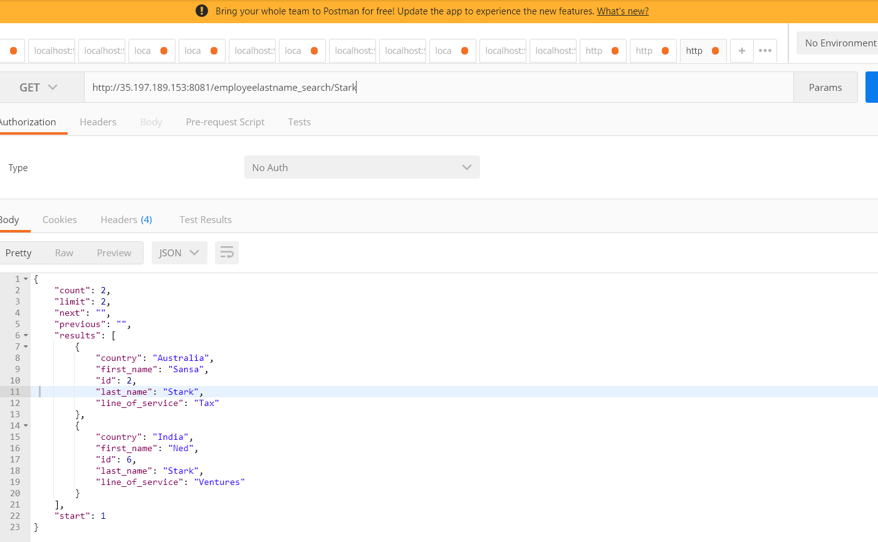

Testcase7: Create an new employee by ID using JSON input

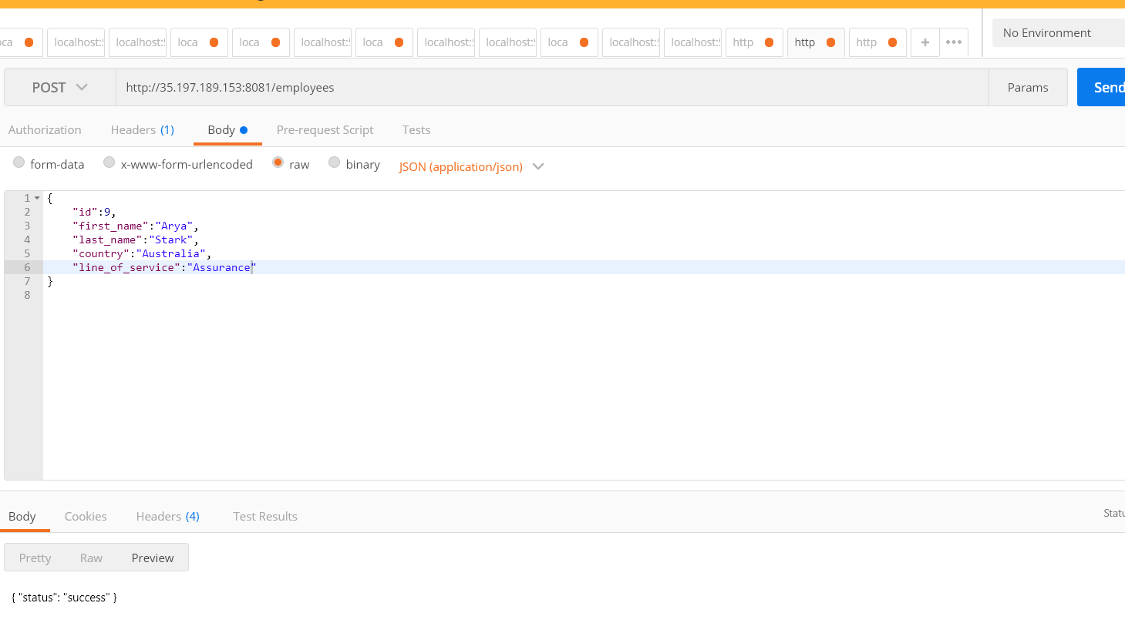

|  |
| --- |
|  |
|  |

|  |
| --- |
| - Web framework: FLASK  1.It is very easy to build and understandable, minimalistic.  2. Faster performance than Django  3. MVC pattern mapping : I have added all components in one single file server.py  Model.py : had schema of your database  Routes.py : routing the API calls --- works as connector to APIs( controller)  Templates folder has html needed for views , API response are rendered to templates mapped to particular html  4. Can reuse and extend forms and templates(html) |
|  |

|  |
| --- |
| - Database: Any of your choosing but you will be required to explain why you chose it |
| I have used SQLITE , WHY :   1. It is faster but not good for production. So its good for enterprise RDBMS like in this case- employee management. 2. An **SQLite** database is normally stored in a single ordinary disk file so its easier for this small test app |
|  |

|  |
| --- |
| - Deployed to a cloud provider of your choosing, bonus points for using GCP |
| -Yes |
|  |

|  |
| --- |
| - Pagination set at two records |
| : Yes |

|  |
| --- |
| - At least three records in the database |
| :Yes |

|  |
| --- |
| - Response should be JSON:  Yes |
|  |

|  |
| --- |
| - Employee record should include id, first name, last name |
| :  Yes |

- Provide testing notes